Addition and Subtraction

I can add and subtract two and three digit numbers using multiple strategies.

Standards:
MGSE2.NBT.5 Fluently add and subtract within 100 using strategies based on place value, properties of operations, and/or the relationship between addition and subtraction.
MGSE2.NBT.6 Add up to four two-digit numbers using strategies based on place value and properties of operations.
MGSE2.NBT.7 Add and subtract within 1000, using concrete models or drawings and strategies based on place value, properties of operations, and/or the relationship between addition and subtraction; relate the strategy to a written method.

MGSE2.NBT.8 Mentally add 10 or 100 to a given number 100–900, and mentally subtract 10 or 100 from a given number 100–900.
MGSE2.NBT.9 Explain why addition and subtraction strategies work, using place value and the properties of operations.

2 Digit Addition Strategies
I can add and subtract two and three digit numbers using multiple strategies.
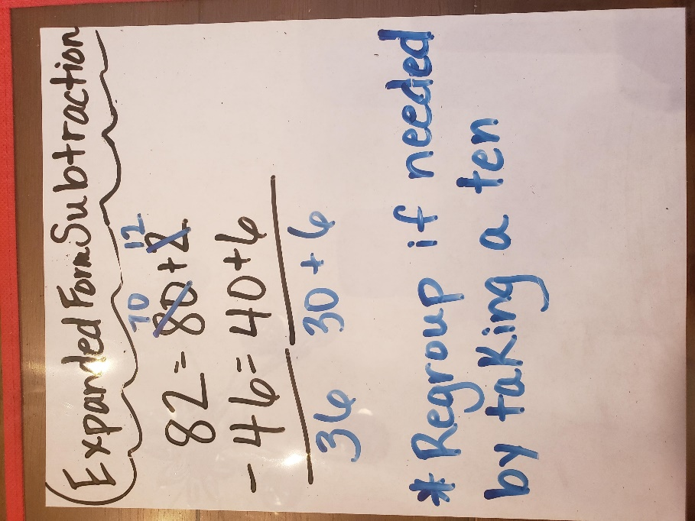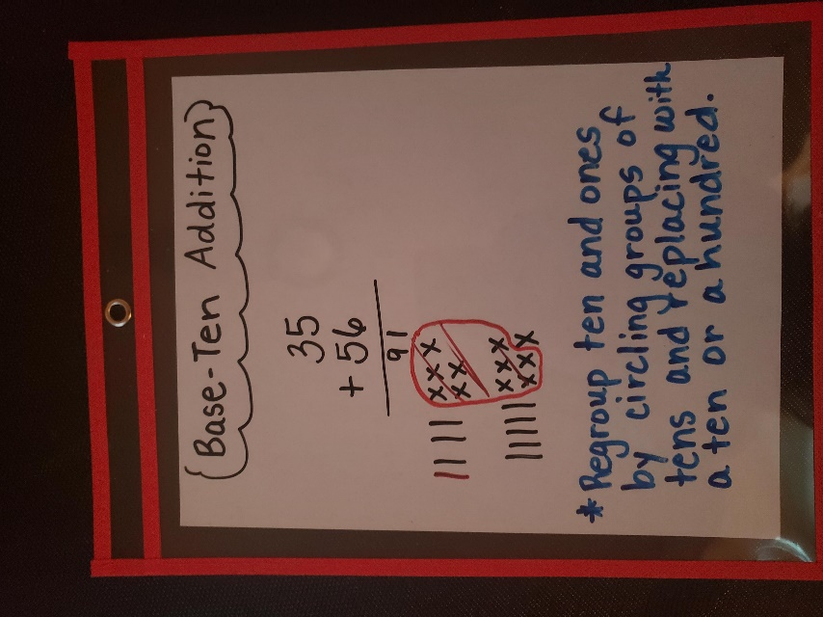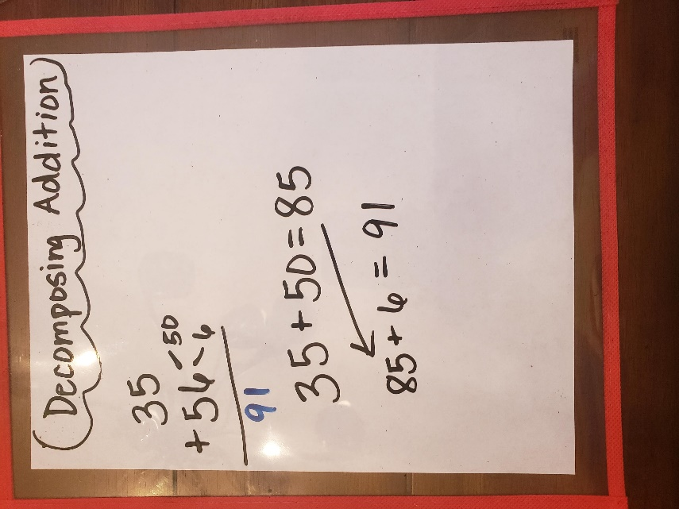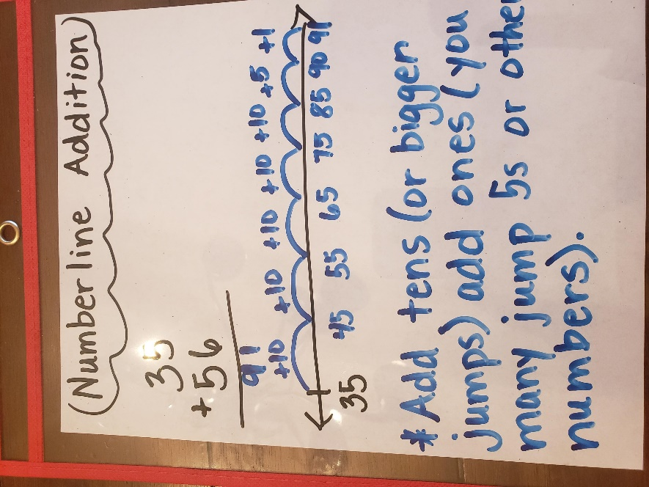
2 Digit Subtraction Strategies
I can add and subtract two and three digit numbers using multiple strategies.
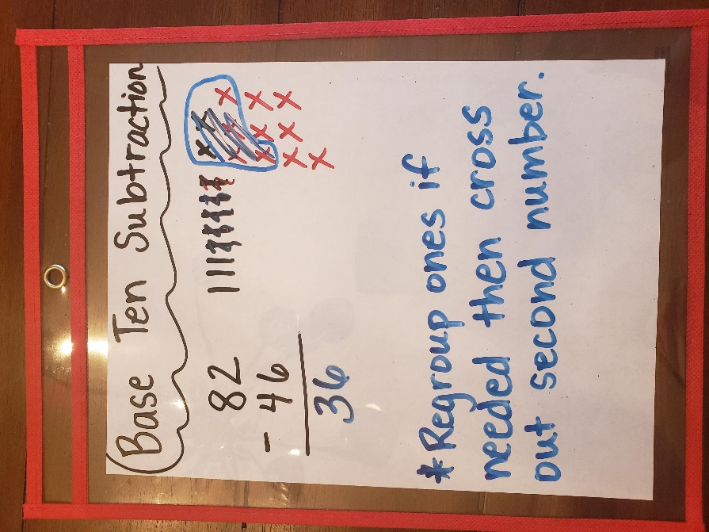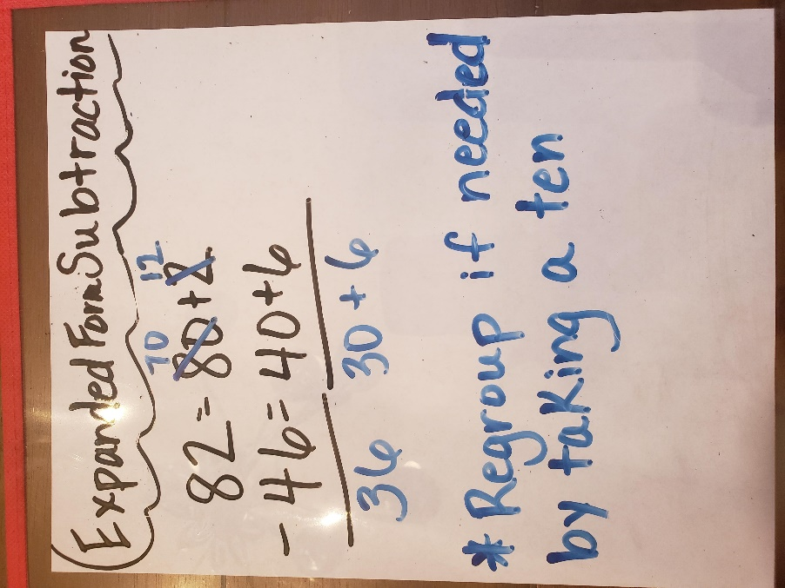
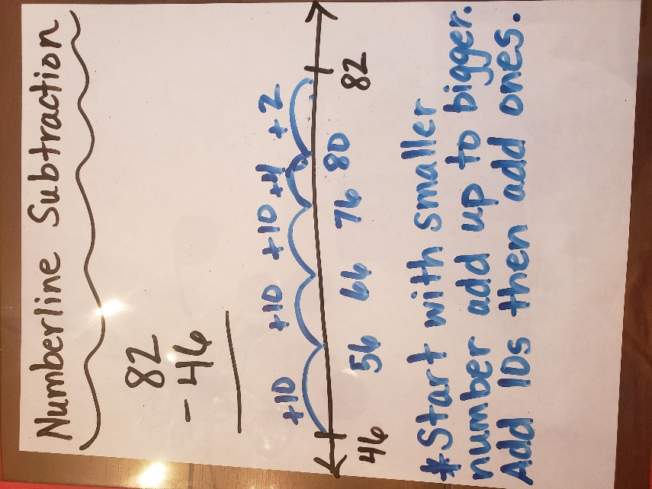
3 Digit Addition Strategies
I can add and subtract two and three digit numbers using multiple strategies.
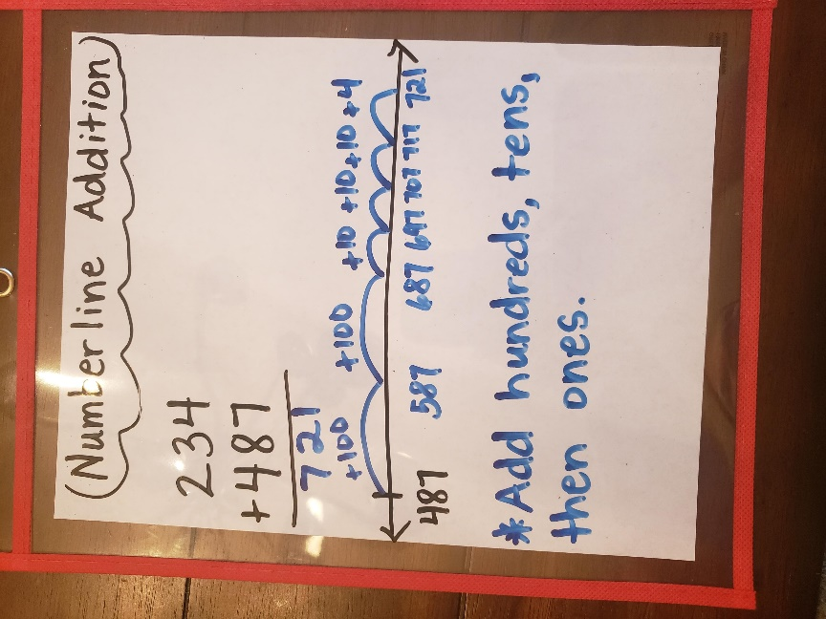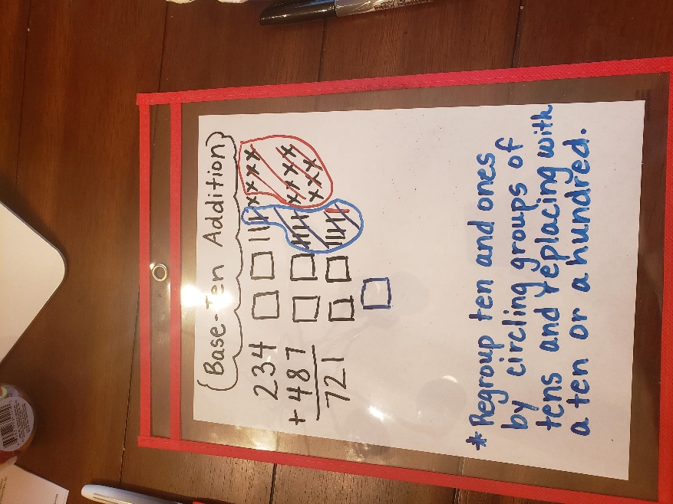
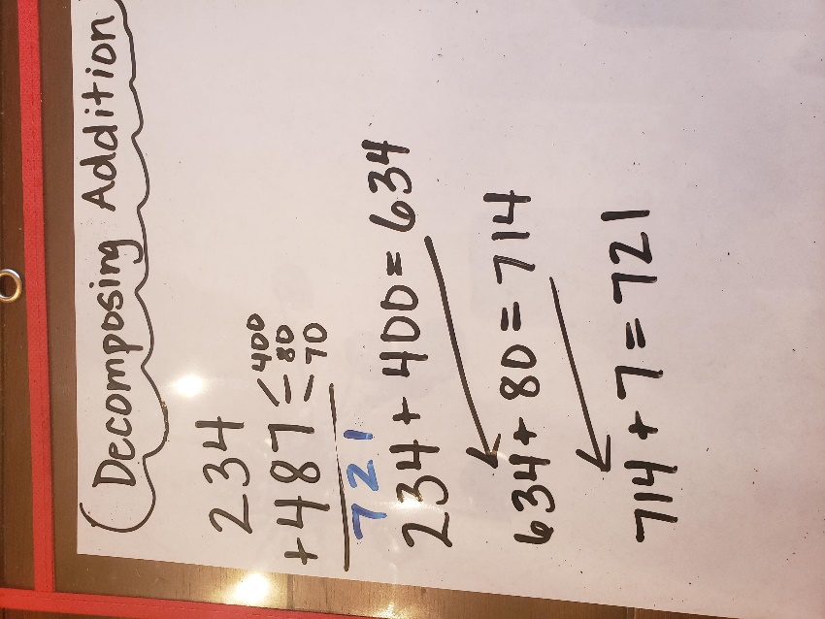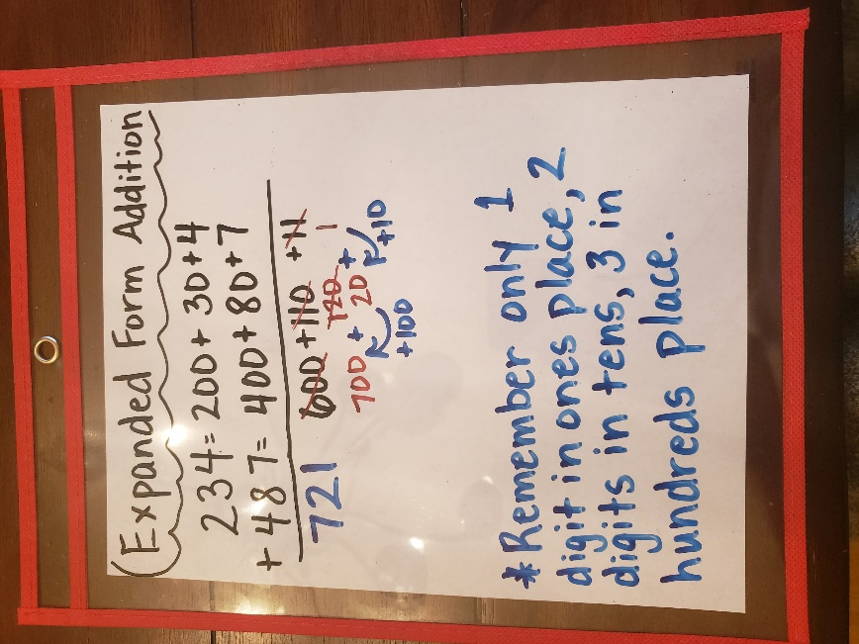
3 Digit Subtraction Strategies
I can add and subtract two and three digit numbers using multiple strategies.
